**Leetcode Problem Solving**

**1) Question 1: (Leetcode 7)**

Write a program to reverse an integer.

**Solution:**

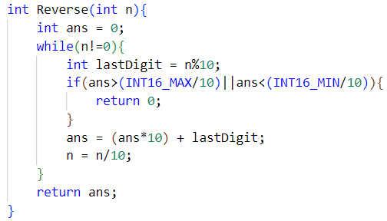

**2) Question 2: (Leetcode 231)**

Write a program to check if a number is power of 2 or not.

**Solution:**

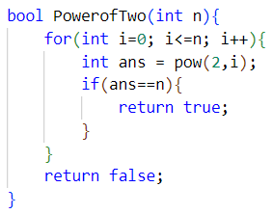

**3) Question 3: (Leetcode 1009)**

Write a program to find bitwise complement (Complement of Base 10 Integer).

**Approach:**

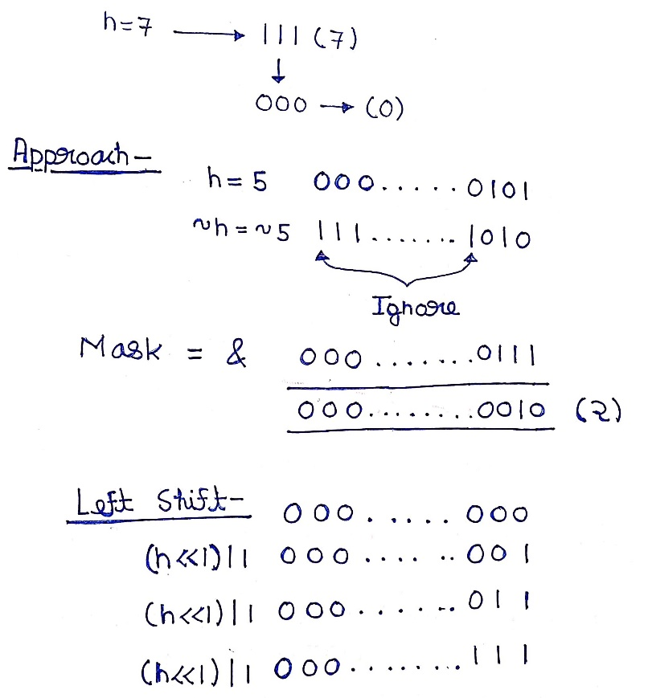

**Solution:**

